Practical-7
Name:- Shubham Sonawane
Roll No:- 4401058
Div-A Batch-D
#include <SoftwareSerial.h>
// RX pin 2, TX pin 3
SoftwareSerial BTSerial(2, 3);
void setup() {
Serial.begin(9600);
Serial.println("Ready to receive AT Commands...");
BTSerial.begin(9600);
}
void loop() {
// Send data from HC-05 to Serial Monitor
if (BTSerial.available()) {
Serial.write(BTSerial.read());
}
// Send data from Serial Monitor to HC-05
if (Serial.available()) {
BTSerial.write(Serial.read());
}
}

OUTPUT:
HARDWARE
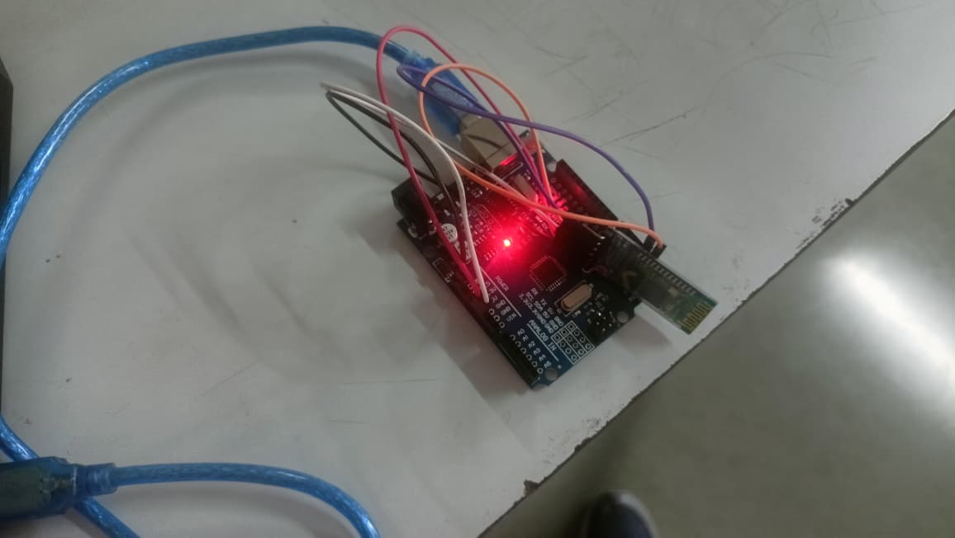

SERIAL TERMINAL
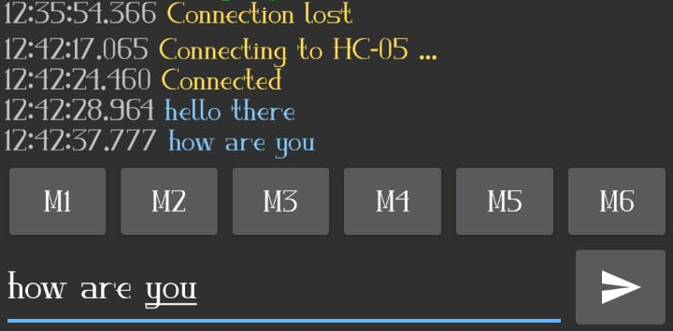
SERIAL MONITOR

